Pull the Hadoop + Ambari Docker image
Docker pull harisekhon/hadoop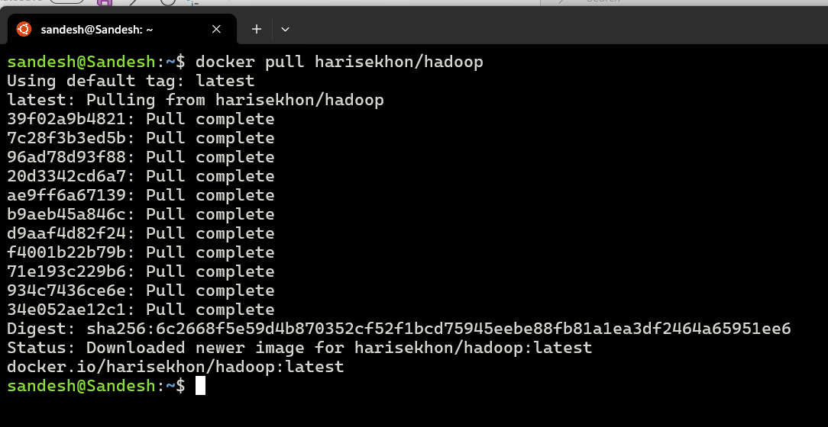

Run the container with exposed ports
docker run -d \
--name hadoop \
-p 9870:9870 \
-p 8088:8088 \
harisekhon/hadoop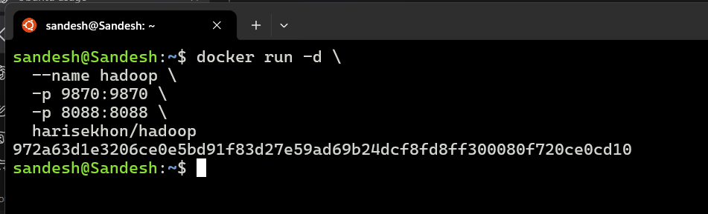

Check container status
docker ps
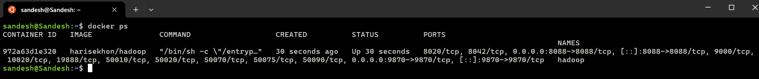

enter container for CLI
docker exec -it hadoop bash
- hdfs dfs -ls /
- yarn node -list
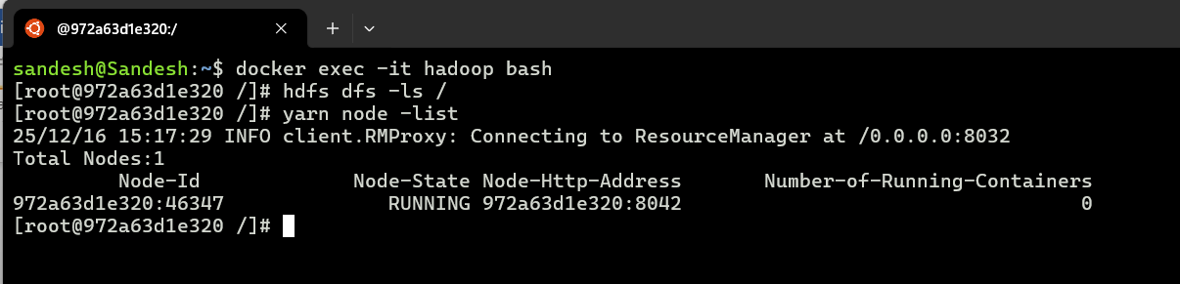

Pull Ambari image
docker pull sequenceiq/ambari
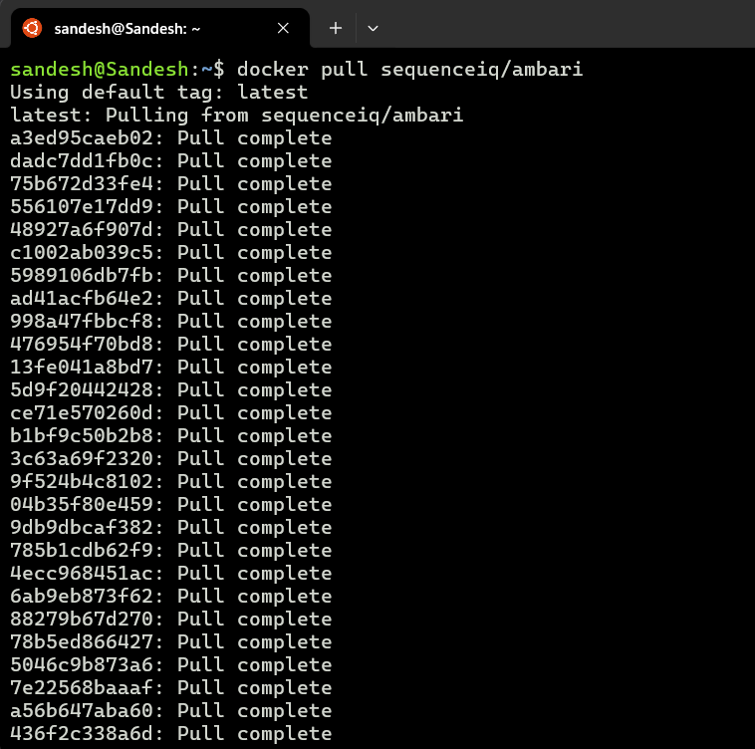

Run it
docker run -d \
--name ambari \
-p 8080:8080 \
--privileged \
sequenceiq/ambari
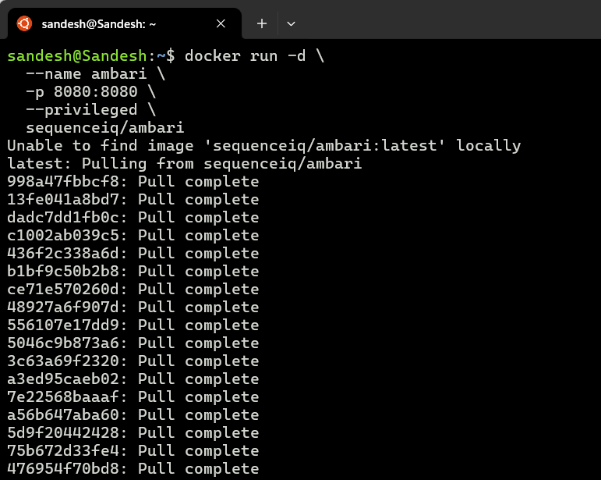

Open browser
http://localhost:8080
admin, admin
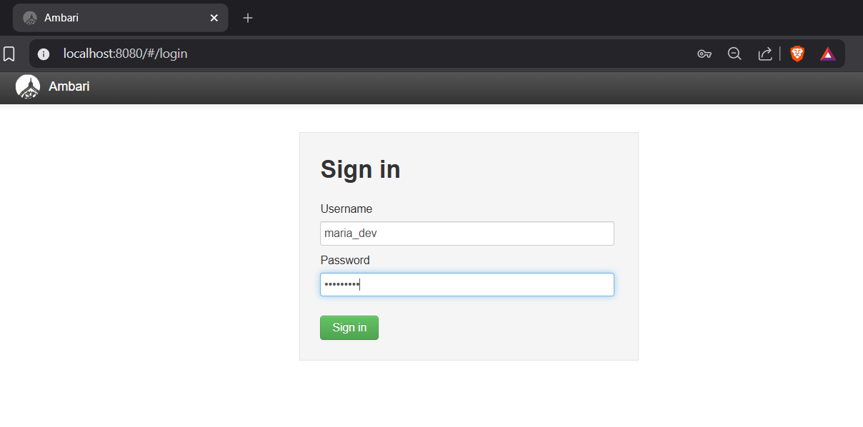

- Go to query
  - Select * from my_user_ratings2 where user_id = 279;a

